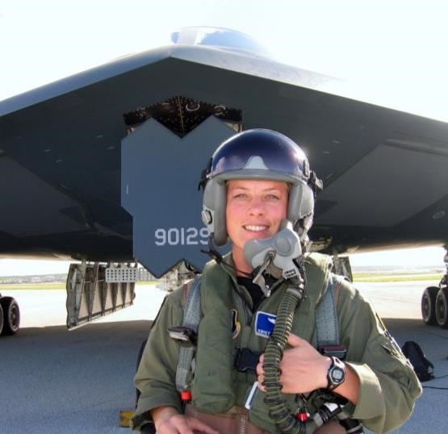

**Gen. Kristin Goodwin, No. 2, Spirit Number 279**

**By Brye Steeves**

**509th Bomb Wing Public Affairs**

Kristin Goodwin is a trailblazer in the truest sense of the word.

She became the Air Force’s first female bomb wing commander in 2014 when she led the nation’s oldest bomber unit, located at Barksdale AFB, Louisiana. Later, she served as the commandant of cadets at the U.S. Air Force Academy – only the second woman to do so – and as a senior military assistant to the Secretary of the Air Force in Washington, D.C., before that.

The path she has forged began at Whiteman AFB, where Goodwin was stationed when she flew the B-2.

On the day of her “dollar ride” on Feb. 12, 2002, Goodwin became airborne just after the B-2 flown by Capt. Jennifer Avery had also taken off from the base’s runway in rural Missouri. Up until that day, more than 200 pilots had flown the stealth bomber since it first took flight in 1989, but all had been men.

Goodwin has pointed to her mother’s 20 years in the U.S. Air Force Reserve, among many other family members’ military service, including her father and both grandfathers, as her inspiration.

"… Family taught me about service, they taught me about sacrifice, and they also taught me about being part of something that's bigger than myself,” Goodwin told the *Shreveport Times* in 2014. “They've been my role models. They've been the embodiment of patriotism, and also have taught me what it means to sacrifice for our nation."

As a child, Goodwin has said she dreamed of flying planes in the Air Force. She graduated from the U.S. Air Force Academy in 1993 and went on to fly the C-130, B-52, B-2 and trainer jets, accumulating thousands of hours as a pilot. She also became a prominent leader – and an inspiration.

According to the Barksdale AFB archives, an Airman who worked with Goodwin said in 2016, “You have also shown us that it is possible to be a mother, spouse and respected professional. That example is something that will stay with me and continue to inspire me to push forward in my aspirations as an Airman, mother and spouse – to create balance in a world that is full of pressure and stress. If Col. Goodwin can do it, so can I!”